**GOSHOP DATABASE**

**Goshop_loyalty**

CREATE DATABASE goshop_loyalty;

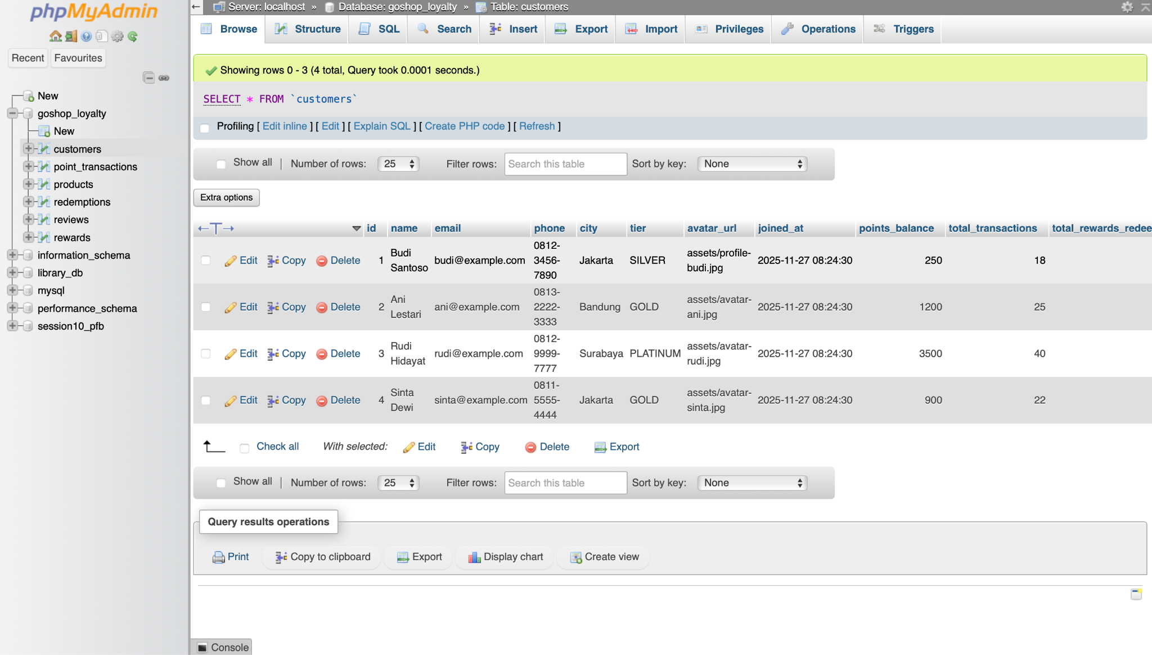

**Customers**

CREATE TABLE customers (

id INT UNSIGNED AUTO_INCREMENT PRIMARY KEY,

name VARCHAR(100) NOT NULL,

email VARCHAR(150) NOT NULL UNIQUE,

phone VARCHAR(30) NULL,

city VARCHAR(100) NULL,

tier ENUM('SILVER','GOLD','PLATINUM') DEFAULT 'SILVER',

avatar_url VARCHAR(255) NULL,

joined_at DATETIME NOT NULL DEFAULT CURRENT_TIMESTAMP,

points_balance INT NOT NULL DEFAULT 0,

total_transactions INT NOT NULL DEFAULT 0,

total_rewards_redeemed INT NOT NULL DEFAULT 0

) ENGINE=InnoDB;



**Point_transactions**

CREATE TABLE point_transactions (

id BIGINT UNSIGNED AUTO_INCREMENT PRIMARY KEY,

customer_id INT UNSIGNED NOT NULL,

type ENUM('EARN','REDEEM','ADJUST_PLUS','ADJUST_MINUS') NOT NULL,

description VARCHAR(255) NOT NULL,

points INT NOT ENUM('STORE','ONLINE','ADMIN','SYSTEM') DEFAULT 'STORE',

created_at DATETIME NOT NULL DEFAULT CURRENT_TIMESTAMP,

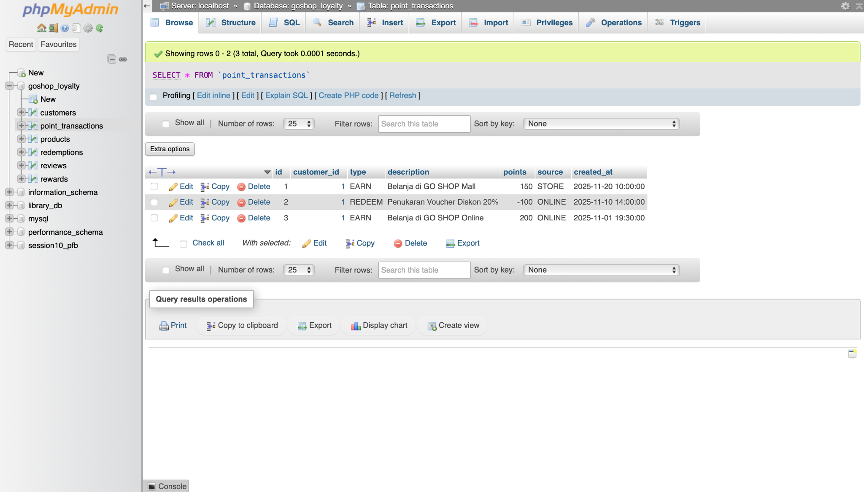

**Products**

CREATE TABLE products (

id INT UNSIGNED AUTO_INCREMENT PRIMARY KEY,

sku VARCHAR(50) NOT NULL UNIQUE,

name VARCHAR(150) NOT NULL,

category VARCHAR(100) NOT NULL,

price INT NOT NULL,INT NOT NULL DEFAULT 0,

image_url VARCHAR(255) NULL,

is_active TINYINT(1) NOT NULL DEFAULT 1,

created_at DATETIME NOT NULL DEFAULT CURRENT_TIMESTAMP,

updated_at DATETIME NULL ON UPDATE CURRENT_TIMESTAMP

) ENGINE=InnoDB;

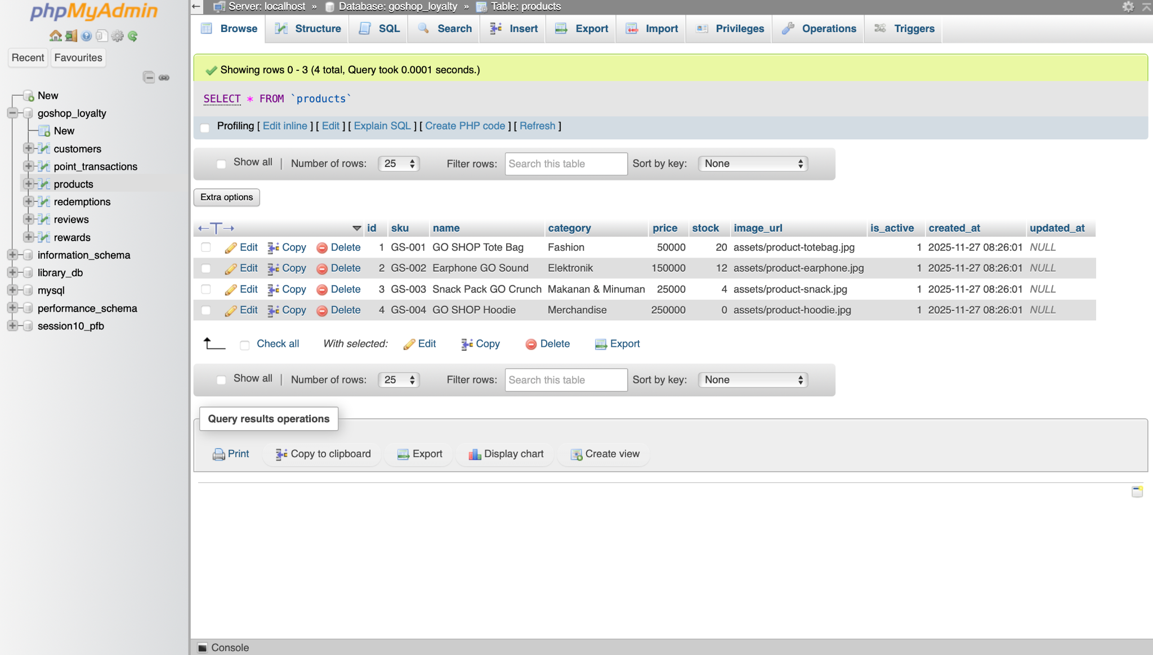

**Redemptions**

CREATE TABLE redemptions (

id BIGINT UNSIGNED AUTO_INCREMENT PRIMARY KEY,

customer_id INT UNSIGNED NOT NULL,

reward_id INT UNSIGNED NOT NULL,

points_used INT NOT NULL,

status ENUM('REQUESTED','APPROVED','REJECTED','CANCELLED') DEFAULT 'APPROVED',

created_at DATETIME NOT NULL DEFAULT CURRENT_TIMESTAMP,

CONSTRAINT fk_redemptions_customer

FOREIGN KEY (customer_id) REFERENCES customers(id)

ON DELETE CASCADE,

CONSTRAINT fk_redemptions_reward

FOREIGN KEY (reward_id) REFERENCES rewards(id)

ON DELETE RESTRICT

) ENGINE=InnoDB;

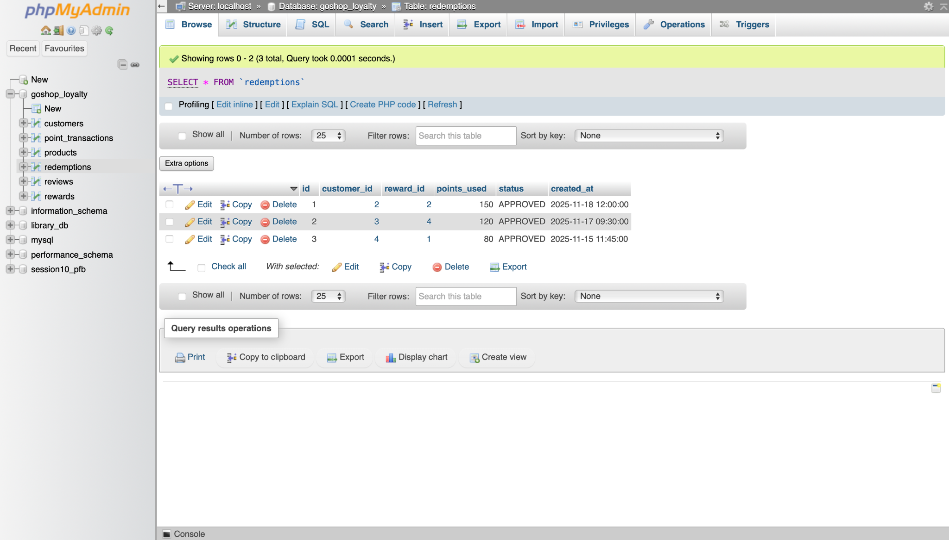

**Reviews**

CREATE TABLE reviews (

id BIGINT UNSIGNED AUTO_INCREMENT PRIMARY KEY,

customer_id INT UNSIGNED NOT NULL,

rating TINYINT NOT NULL CHECK (rating BETWEEN 1 AND 5),

title VARCHAR(150) NULL,

comment TEXT NOT NULL,

created_at DATETIME NOT NULL DEFAULT CURRENT_TIMESTAMP,

CONSTRAINT fk_reviews_customer

FOREIGN KEY (customer_id) REFERENCES customers(id)

ON DELETE CASCADE

) ENGINE=InnoDB;

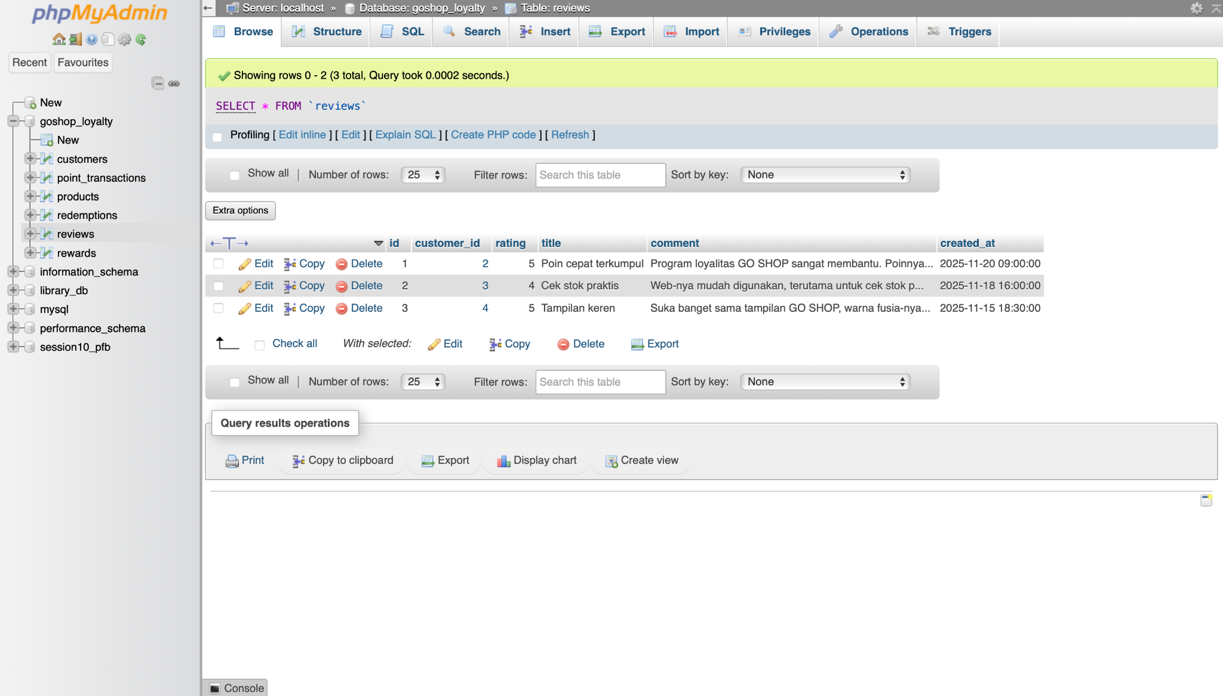

**Rewards**

CREATE TABLE rewards (

id INT UNSIGNED AUTO_INCREMENT PRIMARY KEY,

code VARCHAR(50) NOT NULL UNIQUE,

name VARCHAR(150) NOT NULL,

category VARCHAR(100) NOT NULL,

points_required INT NOT NULL,

stock INT NOT NULL DEFAULT 0,

image_url VARCHAR(255) NULL,

is_active TINYINT(1) NOT NULL DEFAULT 1,

created_at DATETIME NOT NULL DEFAULT CURRENT_TIMESTAMP,

updated_at DATETIME NULL ON UPDATE CURRENT_TIMESTAMP

) ENGINE=InnoDB;

